How to export data from MICRO-300 and MICRO-200 PRO (WIn10 ,win7,Win xp )

Step 1 : Unzip this file

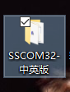
Step 2: OPen sscom32E

Step 3:
Connect tester to your computer with USB

Step 4
Please choose Com5 and open Com

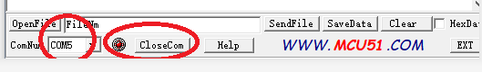

Step 5:
Press “ print data “ on tester , you can export the data .

